**M1-PROJECT PART 2**

**Name: Sunil Raj Thota**

**NUID: 001099670**

**Date: 09/26/2020**

**Title: Executive Summary Report – Part 2**

**Q1. PLOT sales ~ temp to produce a scatter plot**

**A1.**

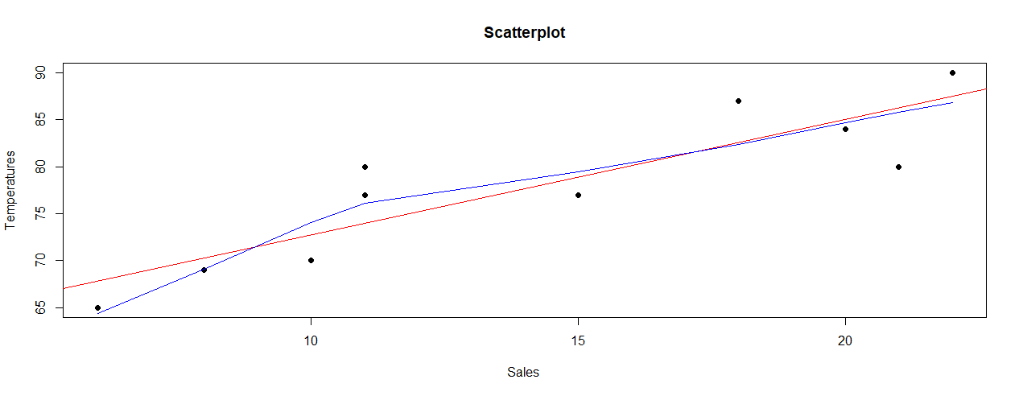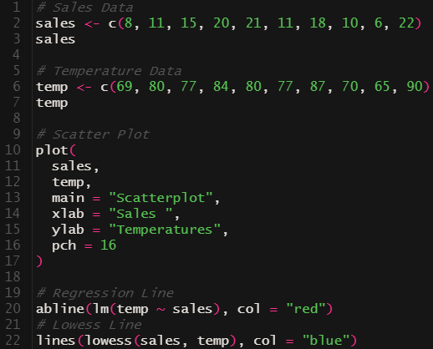

**Q2. FIND the mean temperature**

**A2.**

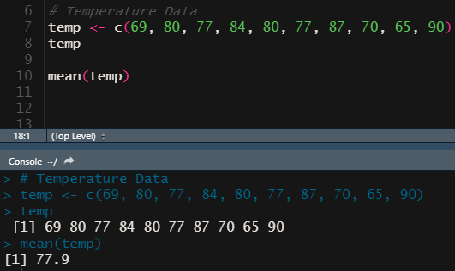

1. **Q3. Google: DELETE the 3rd element (#15) from the sales vector**
2. **A3.**
3. 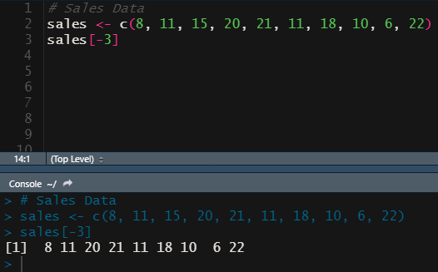
4. **Q4. Google: INSERT 16 as the 3rd element in the sales vector**
5. **A4.**

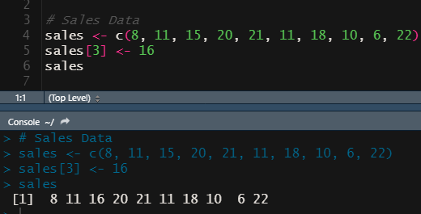

1. **Q5. CREATE a vector < names > with Tom, John, Harry**
2. **A5.**

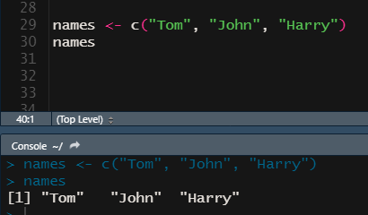

1. **Q6. CREATE a 5 rows / 2 columns matrix of 10 integers (1 to 10)**
2. **A6.**
3. 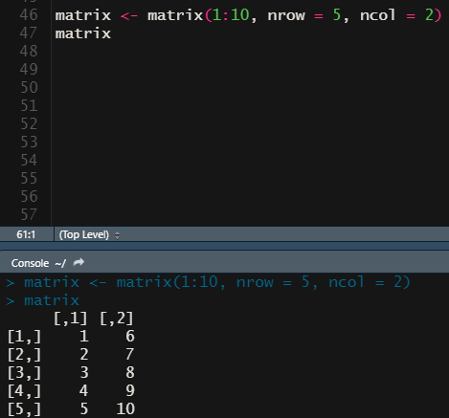
4. **Q7. CREATE <icSales> dataframe with sales & temp vars**
5. **A7.**
6. 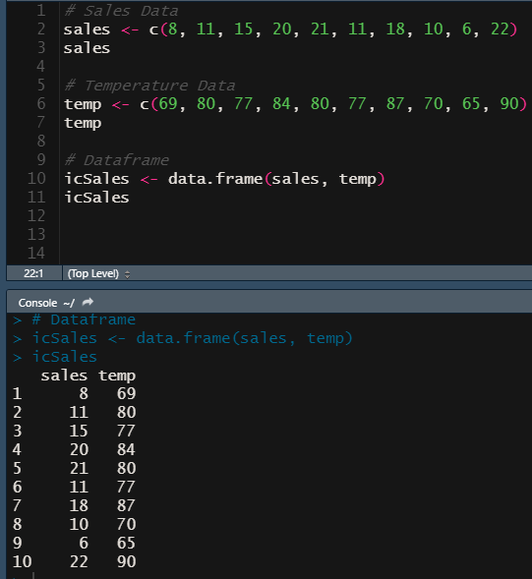
7. **Q8. DISPLAY a summary and structure of the icSales data frame**

**A8.**

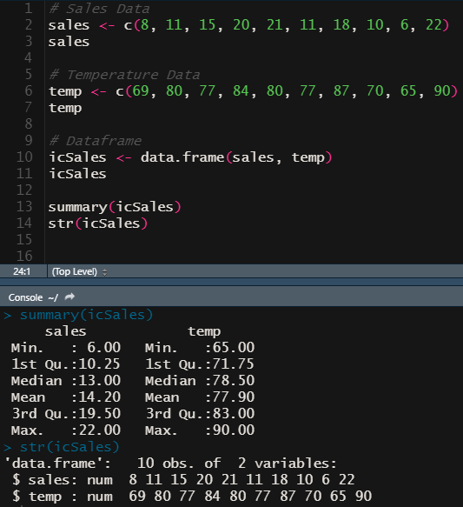

1. **Q9. IMPORT the attached data set as Student.csv.**
2. **A9.**
3. 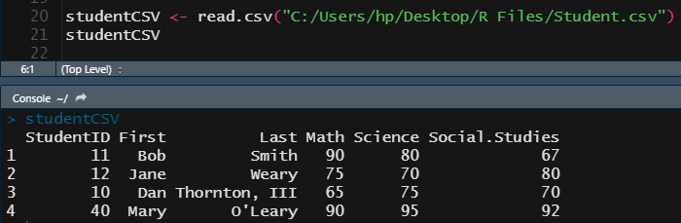
4. **Q10. Obtain the means for Math, Science and Social Studies and create a vector named All_means. Create a vector named All_labels containing Math, Science and Social Studies, and finally present this data using a data frame.**
5. **A10.**

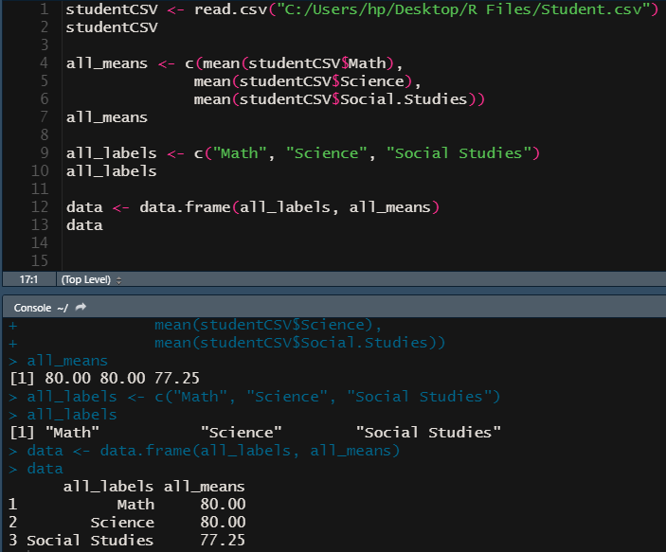

1. **Q11 Present key Summary Descriptive Statistics for the data set Student.csv.**
2. **A11.**
3. 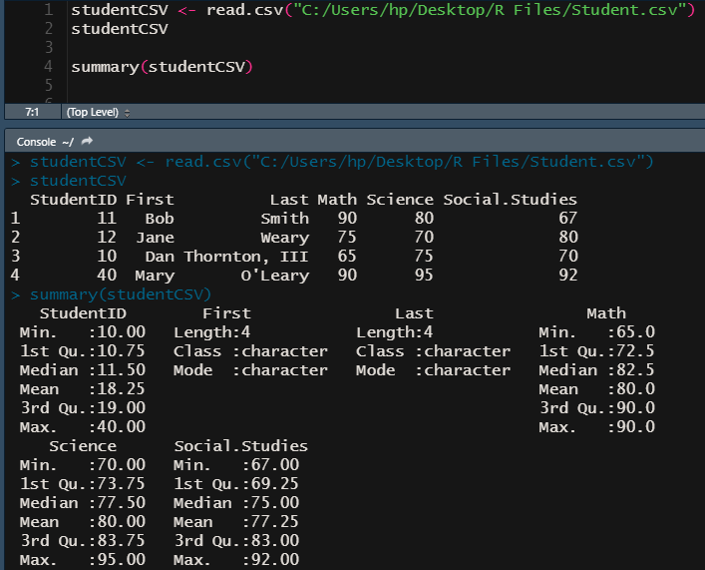
4. **Q12 Present bar graphs for each student (using their last names) and their corresponding Math, Science and Social Studies scores (you can present one or three independent bar graphs). Hint, use? bar plots to find additional information.**

**A12.**

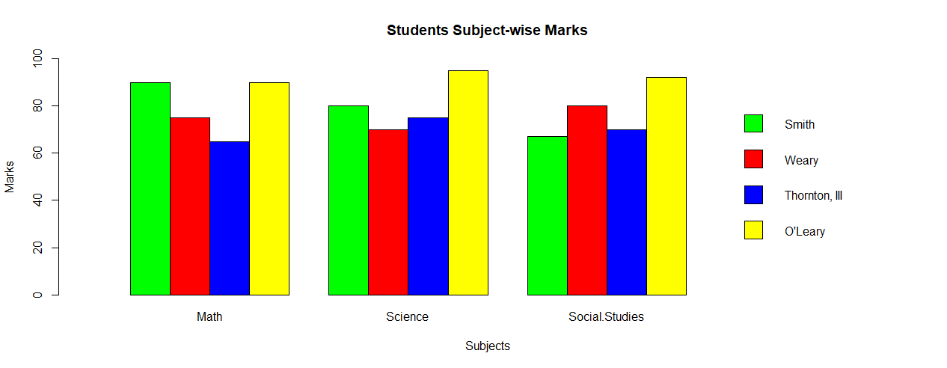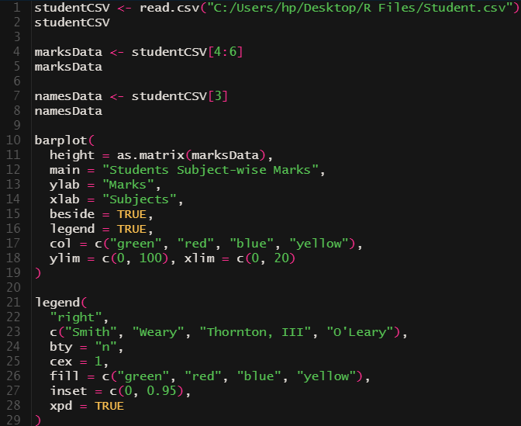

**Bibliography:**

1. <https://stackoverflow.com/questions/27688754/bar-chart-legend-position-avoiding-operlap-in-r>
2. <https://stackoverflow.com/questions/3932038/plot-a-legend-outside-of-the-plotting-area-in-base-graphics>
3. <https://www.dataanalytics.org.uk/legends-on-graphs-and-charts/>
4. <https://www.statmethods.net/graphs/bar.html>